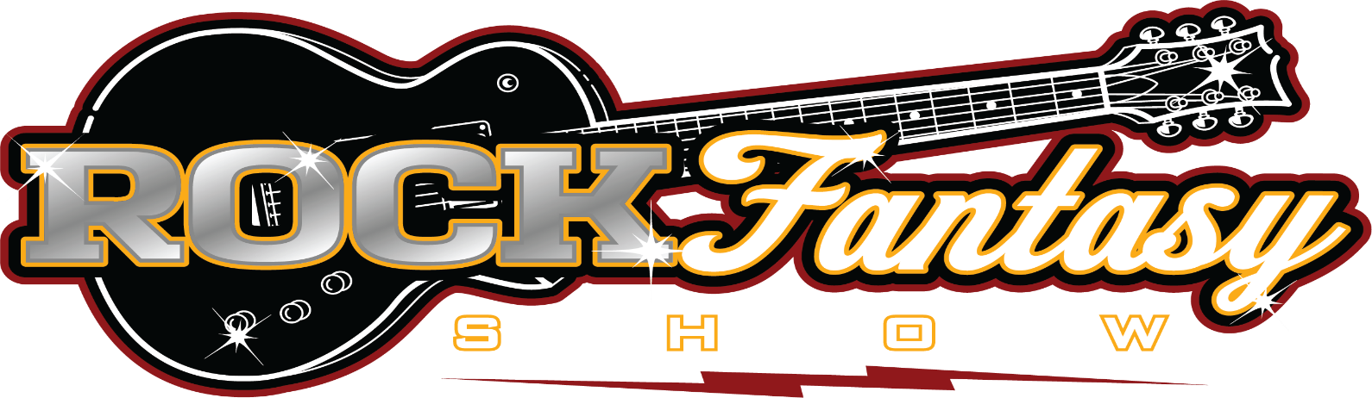
ROCKSTARS & TRIBUTE SINGERS UNITE IN THIS BEST OF BOTH WORLDS
PRODUCTION SHOW
FEATURING PAST AND PRESENT MEMBERS OF THE FIRM, JOURNEY, THE CULT, WHITESNAKE, GREAT WHITE, LITA FORD, ASIA, SOCIAL DISTORTION, MISSING PERSONS, AND MANY MORE!!!
SHOW BIO
Straight from Las Vegas, Internationally acclaimed ROCK FANTASY possesses the greatest collection of celebrity tribute artists ever assembled. Featuring live concert shows of famous singers and celebrities of yesterday and today. This show will take you back in time to when Classic Rock Superstars ruled the music scene. And to take it all to the next level the musicians are past and present members of Asia, Journey, The Firm, The Cult, Lita Ford, Whitesnake, Great White and many many more!!!

The ROCK FANTASY team sought out the best “Rock Legend Singers” Then worked alongside the Top Sound/Lighting Professionals and Legendary Rock Photographers to create a fresh unique way of bringing to life “The Perfect Rock Show”.
The concept is based on the ability to create the line up that a Talent Buyer, Booking Agent, and even a Rock n Roll Fan can customize to truly put on “Their Own Ultimate ROCK FANTASY Show”.
ROCK FANTASY is perfect for Casinos, Music Festivals, Cruise Ships, Corporate Events, Private Parties, Rock Clubs, Theaters, Festivals and Concert Events for any occasion throughout the US and internationally
ROCK FANTASY entertainers have sold millions of albums, earned entertainment industry awards including "Vocalist of the Year," and "Entertainers of the Year" proving this is the WORLD’S GREATEST LIVE TRIBUTE SHOW. ROCK FANTASY with music legends, such as Robert Plant, Freddy Mercury, The Rolling Stones, Kiss, Steve Perry, David Lee Roth, Axl Rose, Jon Bon Jovi, David Bowie, Bono, Elton John, Heart, Stevie Nicks, Rod Stewart, Pat Benatar, Bruce Springsteen, Mick Jagger, Madonna, Stevie Nicks, Joe Elliott, Vince Neil and many more celebrities that appeal to music fans of all ages make ROCK FANTASY a must-see live concert show.
ROCK FANTASY live tribute shows are known for their elaborate concert settings, magnificent costumes and full array of incredible special effects, including state-of-the-art lighting, laser and sound systems. An outstanding cast of accomplished celebrity look-alike and sound-alike performers, and a live band comprised of the top musicians in the industry, support each ROCK FANTASY production.
While maintaining the integrity of the original performer, many of the ROCK FANTASY singers have performed with and/or have been praised by the original artist they pay homage to. This is not smoke and mirrors - this is the CHANCE to create a ROCK FANTASY for your audience …and have it all come true....
ROCKFANTASYSHOW.LIVE

